**Unknown Cyber Portal and User Protection Setup Guide**

Contents

1. Open your browser to unknowncyber.com and then select “Register” from the top menu. 3

2. Fill out the membership form and click Sign Up. 3

3. You will receive an email similar to the one below. Follow the link to complete your activation. 4

4. Click Verify 4

5. Put in your credentials and click Sign In. 5

6. You will now see the Portal Home Page 6

7. Click your user icon in the upper right corner, then click Settings. 7

8. Click “Exchange Settings → Connect Exchange” 7

9. Populate the “Tenant ID”, “Client ID”, “Client Secret”, and (optional/recommended) “Sentinel Workspace ID” from your vault or saved document from the user setup guide to the fields indicated below and then click “Subscribe”. 8

10. Wait 5-7 minutes for the connection to complete initialization and then the “Subscribe/Unsubscribe” users and “Subscribe/Unsubscribe Groups” will now be selectable. 9

11. You can now select or deselect users for subscribing to Unknown Cyber protection and then click “Submit” to apply the changes. 10

# Open your browser to unknowncyber.com and then select “Register” from the top menu.

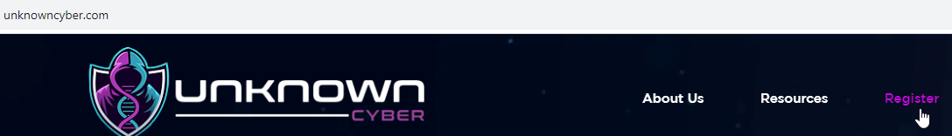

# 2. Fill out the membership form and click Sign Up.

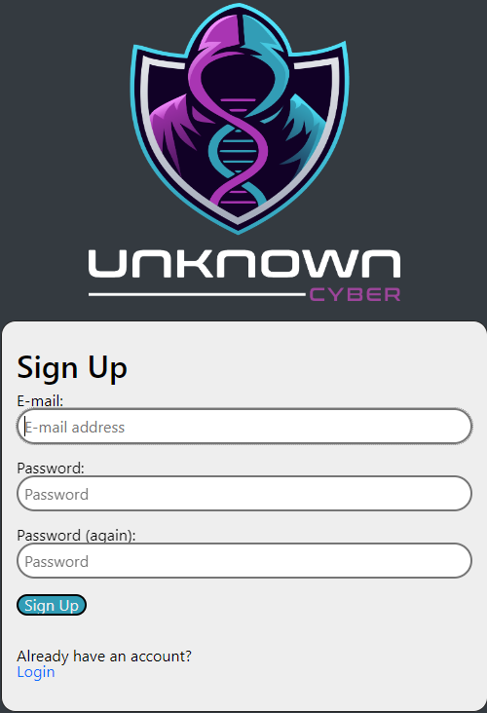

# 3. You will receive an email similar to the one below. Follow the link to complete your activation.

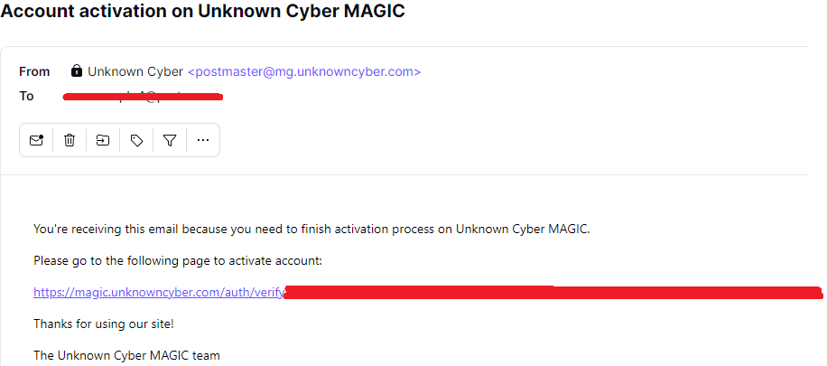

# 4. Click Verify

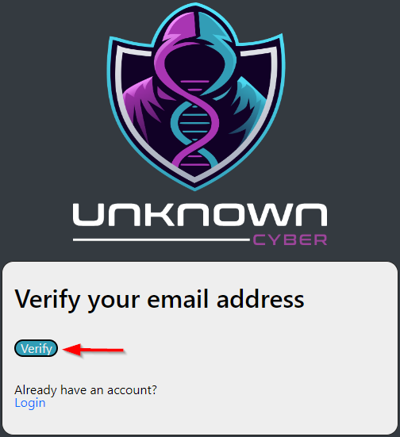

# 5. Put in your credentials and click Sign In.

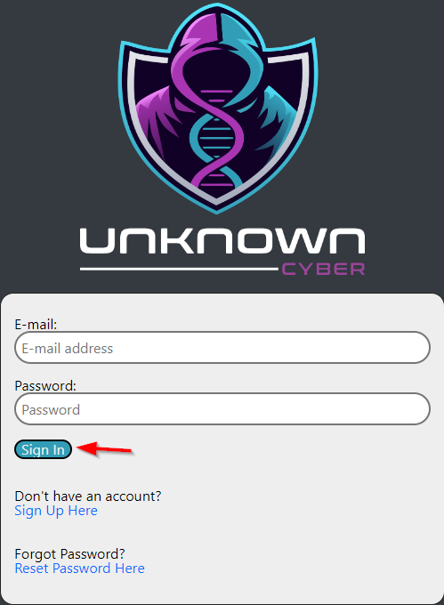

# 6. You will now see the Portal Home Page

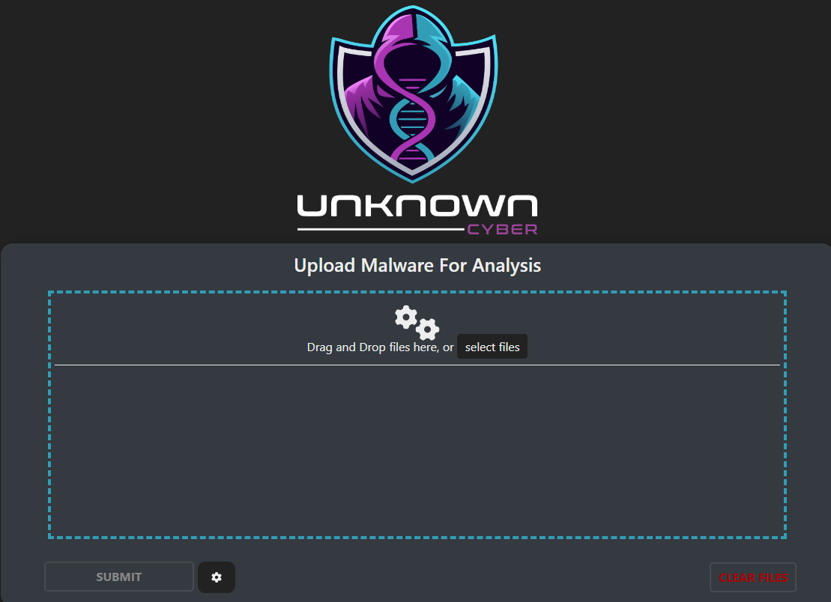

# 

# 7. Click your user icon in the upper right corner, then click Settings.

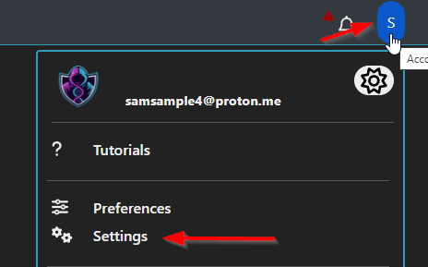

# 8. Click “Exchange Settings → Connect Exchange”

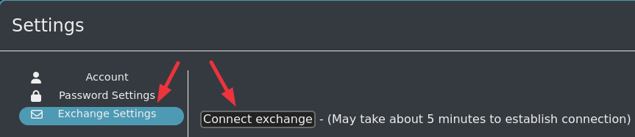

# 9. Populate the “Tenant ID”, “Client ID”, “Client Secret”, and (optional/recommended) “Sentinel Workspace ID” from your vault or saved document from the user setup guide to the fields indicated below and then click “Subscribe”.

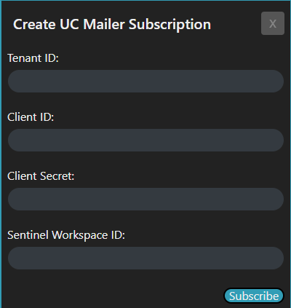

# 10. Wait 5-7 minutes for the connection to complete initialization and then the “Subscribe/Unsubscribe” users and “Subscribe/Unsubscribe Groups” will now be selectable.

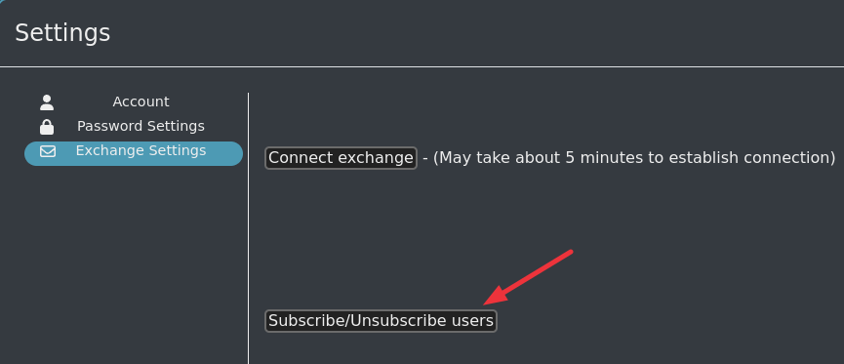

# 11. You can now select or deselect users for subscribing to Unknown Cyber protection and then click “Submit” to apply the changes.

